Temasek Polytechnic

School of Informatics and IT

**Diploma in Information Technology (IT)**

Software Requirement Specifications (SRS)

**Project Particulars**

|  |  |
| --- | --- |
| **Tutor** | Mr Mel Goh |
| **Class** | P04 |
| **Project Title** | Delonix Regia Hotel Management System |

**Project Team’s Particulars**

|  |  |
| --- | --- |
| **Matric Number** | **Student Name** |
| **1406932B** | **Daniel Toh** |
| **1400797E** | **Edmund Yeo** |
| **1407193J** | **Dominic Ng** |
|  | **Vivian Tan** |

Revision History

|  |  |  |  |
| --- | --- | --- | --- |
| **Date** | **Version** | **Description** | **Author** |
| 24/5/2016 | 1 | Done up 2.1, 2.2, 2.3, 2.4, 2.5 | Daniel |
|  |  |  |  |
|  |  |  |  |
|  |  |  |  |

**Table of Contents**

1. DISTRIBUTION OF WORKLOAD 4

2. OVERVIEW OF REQUIREMENTS 4

2.1 System Functions 4

2.2 User Characteristics 4

2.3 General Constraints 4

2.4 Functional Requirements 4

2.5 Data Requirements 4

2.6 User Interface Requirements 5

2.7 Interface with Other Systems 5

2.8 Assumptions 5

3 OPERATIONAL AND QUALITY REQUIREMENTS 5

3.1 Operating Environment 5

3.2 Development Constraints 5

3.3 Performance 5

3.4 Availability 5

3.5 Security and Access Control Requirements 6

4 SPECIAL REQUIREMENTS 6

5 REFERENCES 6

# DISTRIBUTION OF WORKLOAD

|  |  |
| --- | --- |
| **Requirement Gathering** | **Members** |
| 2.1, 2.2, 2.3, 2.4, 2.5 | Daniel |
| 3.1, 3.2, 4, 5 | Edmund |
| 3.3, 3.4, 3.5, 5 | Vivian |
| 2.6, 2.7, 2.8 | Dominic |

# OVERVIEW OF REQUIREMENTS



## System Functions

|  |  |
| --- | --- |
| ***Features Planned For:*** | ***Description*** |
| *Front Office* | * Managing customers who check-in or out * Updating of room status * Cashier report * Room statistic report * Room performance report |
| *House Keepers* | * Room Servicing Request Room * Servicing History * Laundry Request |
| *Finance* | * Summary of Sale * Total monthly report * Yearly F&B Sale Report |
| *Store Manager* | * Item Stock * Vendor Report * Stock Statement * Issue Register |
| *Online Booking Engine* | * Smartphone Supported * Easy to use Interface Reviews Columns * Pre-Arrival Options for Customers |

## User Characteristics

**Department who uses the System**

1. Management
2. Front Office
3. House Keepers
4. Finance
5. Store Management
6. F&B
7. Human Resource

***Users in Each Departments***

**The Rooms Division**

* **Front office**
  + Guest Service Agent (GSA)
* **Housekeeping**
  + Laundry attendants
  + Room attendants
  + Inspectors
* **Uniformed services**
  + Bell-staff
  + Doorperson
  + Valet
  + Concierge

**The Food and Beverage Division**

* Restaurant
* Specialty restaurant(s)
* Catering department

**The Sales and Marketing Division**

* Convention Service Department
* Public relations
* Accounting
* Controller
* Bookkeeper

**The Maintenance Department**

* Maintenance personnel
* Internal security
* External security

**Human Resource**

* Employment
* Employee relations
* Labour relations

**Description of how each department uses the system**

*Management Team*

The management team will use the system to get daily/weekly reports of the business to get a clear look at how the business is currently running. With the system, they are able look at the business current sales revenue, current supply stock and supplier information to get updated information to make decision.

Front office

The front office team is able to use the system to book a hotel room for the customer based on reservation like on-site booking, off-site booking. The system will also be able to notify the front office team if there are any hotel room service that is required and then the front office team will schedule the required service for that customer. The system also allows the receptionist to update any room on the hotel to make sure every room is properly allocated to each customers.

*Finance Team*

For the finance team they will be able to get access all of the employee’s information and the company’s budget information. The finance team will be able to use the system to check when the next bill is coming in and how much the estimate cost would be. The system will also be able to issue out pay checks towards the employee each month.

*Maintenance Team*

For the maintenance team, they will be able to use the system to get information on all of the filed required maintenance service and also to schedule a time and date for the service to be taken place.

Human Resource Team

They are able to use the system to get information on each employee and also update the employee information.

*F&B Team*

With the hotel management software, they can handle the reservation also for the restaurant same as the receptionist as the front office and also get notification on the required food needed to send to the hotel guest. The team is able to use the system to generate a new menu and also update the menu.

## General Constraints

The front office system must always be up and running as the F&B Team, Maintenance Team depends on the system to be able to get the information needed. So let’s say for example, if someone requested for food to be send towards him/her the information must be updated in the front office system and the information will be shared towards the F&B system. Vice Versa same goes for all the system, all must be up and running properly for the management team to get the needed information.

*Existing Software on the Market Now*

1. roomMaster
2. Resort Data Processing
3. Frontdesk Anywhere
4. GuestPoint
5. RoomKeyPMS
6. Hotelogix
7. ASI FrontDesk
8. RMS
9. InnTender

## Functional Requirements

*Front Desk Department*

* The system should allow the receptionist to book a room for the customer.
* The system should allow the receptionist to make a reservation at the hotel restaurant for the customer.
* The system should allow the receptionist to schedule a service maintenance for the maintenance team to service.
* The system should allow the receptionist to schedule a food catering to the customer room.
* The system should allow the receptionist to search for the hotel room by room number
* The system should allow the receptionist to schedule laundry request

*Human Resource Department*

* The system should allow the human resource personnel to retrieve the list of all the employees of the organization.
* The system should allow the human resource personnel to update a specific employee’s data on the database.
* The system should allow the human resource personnel to search for the employee by their name or id.
* The system should allow the human resource personnel to retrieve duty roster
* The system should allow the human resource personnel to create a new employee data.
* The system should allow the human resource personnel to delete a specific employee data.

*Finance Department*

* The system should allow the finance personnel to retrieve the business budget.
* The system should allow the finance personnel to check the next pay cycle.
* The system should allow the finance personnel to send pay check to the employee.
* The system should allow the finance personnel to send cheques to pay for monthly supplies.
* The system should allow the finance personnel to generate sales report.

*Maintenance Department*

* The system should allow the maintenance personnel to retrieve all requested maintenance service.
* The system should allow the maintenance personnel to schedule a timeslot of the request service.
* The system should allow the maintenance personnel to view all of the complete servicing.
* The system should allow the maintenance personnel to request to purchase parts for needed servicing.

*F&B Department*

* The system should allow the F&B personnel to create a food menu.
* The system should allow the F&B personnel to update the food menu.
* The system should allow the F&B personnel to retrieve all requested food for the hotel guest.
* The system should allow the F&B personnel to delete a food menu
* The system should allow the F&B personnel to retrieve all completed orders.
* The system should allow the F&B personnel to request money from the finance department to buy ingredients.

*Management Department*

* The system should allow the management personnel to retrieve daily/weekly reports of the business.
* The system should allow the management personnel to retrieve employee’s information.
* The system should allow the management personnel to retrieve all supplier’s information.

*Store Manager Department*

* The system should allow the store manager personnel to generate vendor report.
* The system should allow the store manager personnel to display stock statement.
* The system should allow the store manager personnel to issue register.

*Guest*

* The system should allow guest to do booking
* The system should allow guest to edit their existing booking
* The system should allow guest to cancel their booking
* The system should allow guest to guest to manage their account
* The system should allow guest to register for an account
* The system should allow guest to view available room

## 2.5 Data Requirements

|  |  |  |
| --- | --- | --- |
| Data Required for the System | | |
| Employee Details | House Keepers Details | Reservation Details |
| Supplier Details | Paycheck Details | Hotel Guest Details |
| Hotel Room Details | Food Order Details | Restaurant Customer Details |
| Maintenance Parts Details | Completed Order Details |  |
| Restaurant Menu ID | Maintenance Service Details |  |

## User Interface Requirements

# 

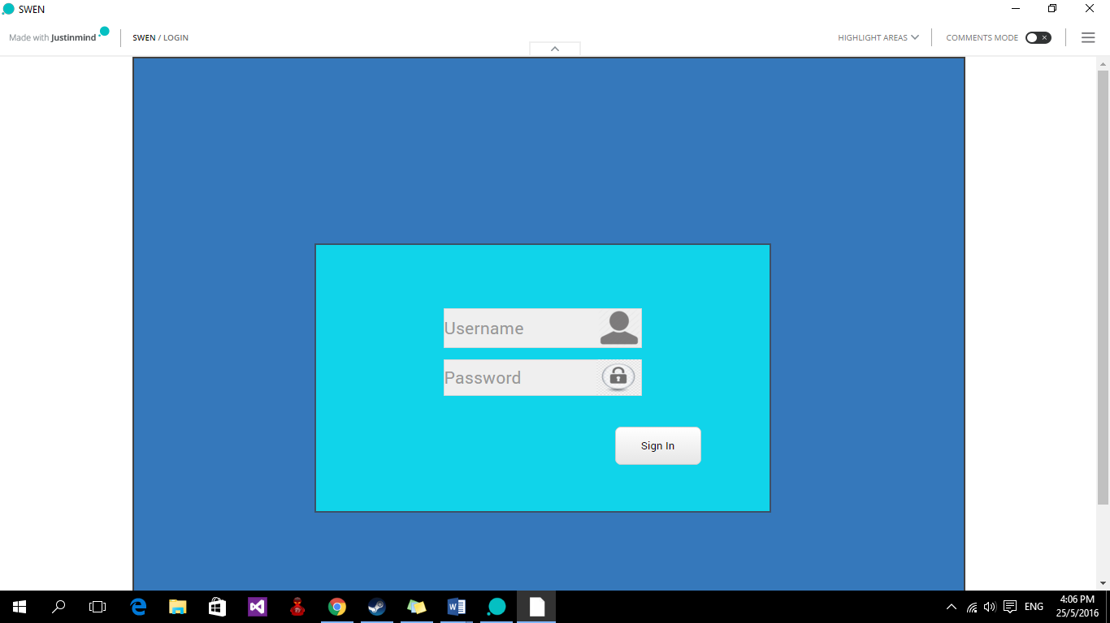

The company employee will be given a Username and Password to login before they could use the company system.

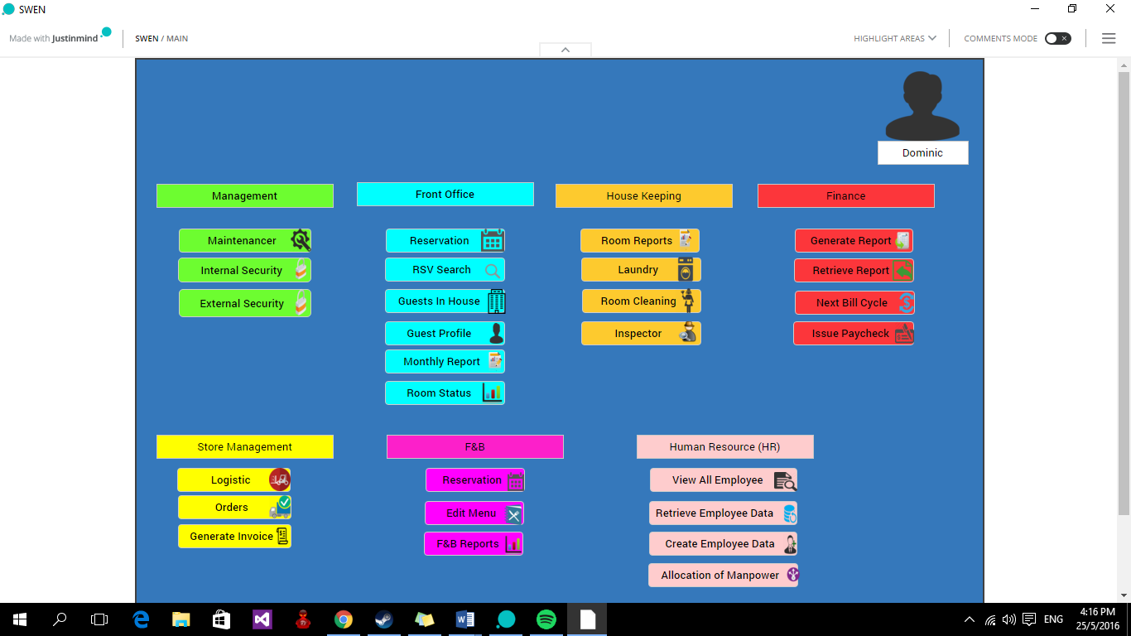

After user have login the system will show your profile picture and also your name below your profile picture. I have also categorized the different department by using colors so that users will be easier to find the department that they are in. Next picture will show you what will happen when a staff click on the reservation button.

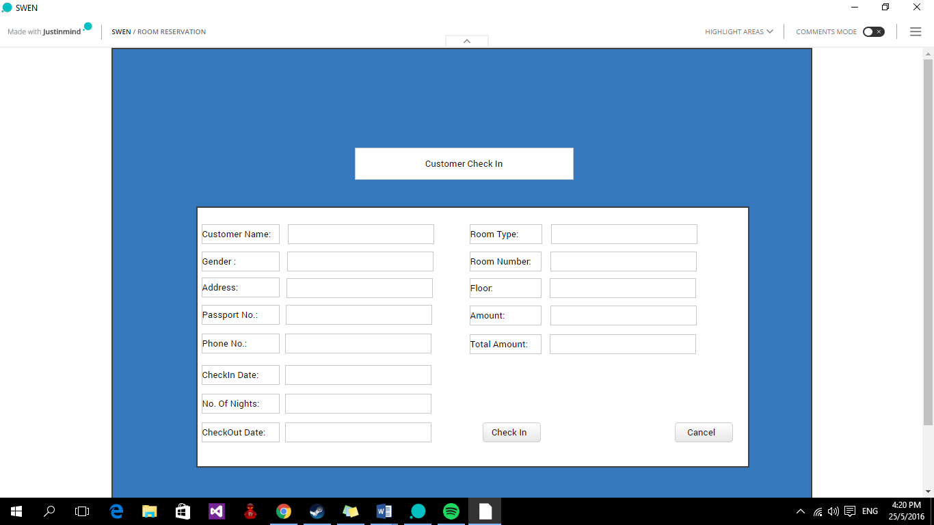

After the staff click on the reservation button it will bring them to this page where the staff can help the guest to fill in their details and the room number that the guest is going to stay in and how much is the total that the guest have to pay.

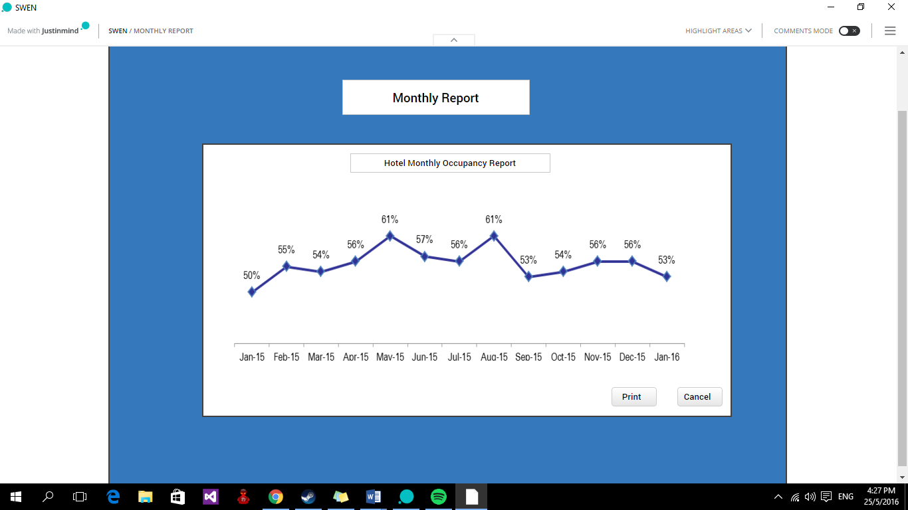

In this picture you will see the monthly report of the occupancy in the hotel. The CEO can just login and click on the Monthly Report and it will bring him to this page where the CEO can see how’s the hotel occupancy doing is it getting better or is it getting worse.

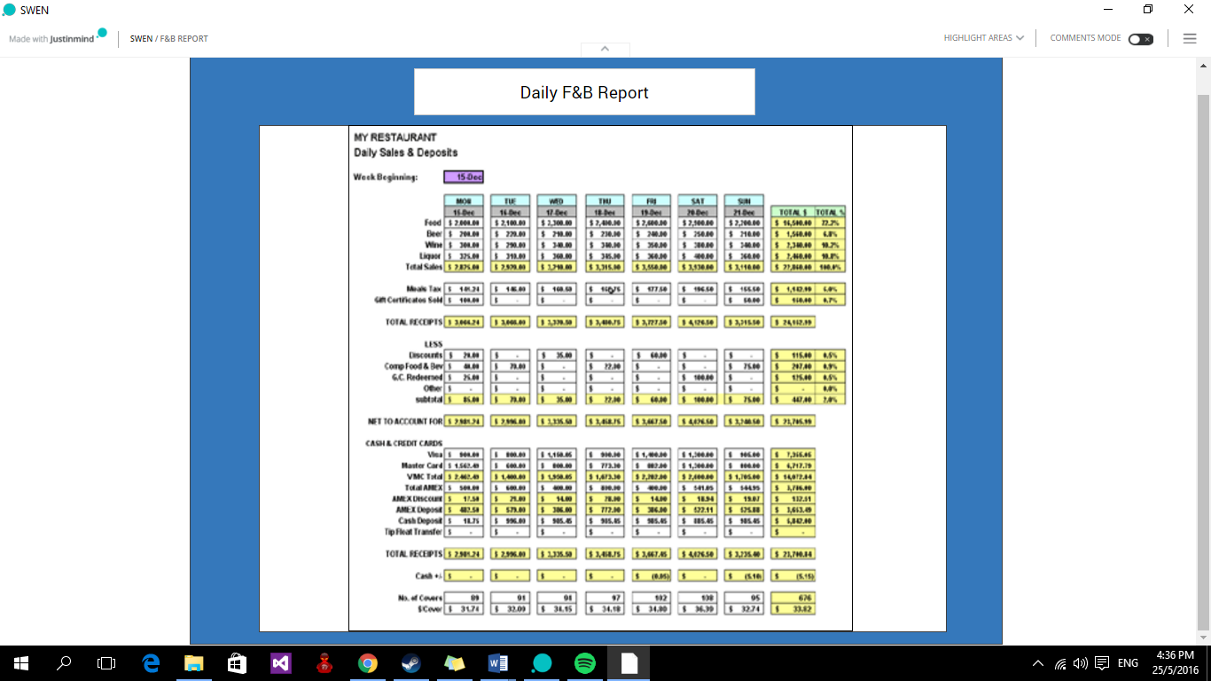

In this picture it shows you the Daily F&B Report. This allows the CEO to see how the F&B sales is doing like are they losing money or earning profits. This page can be view by just clicking on.



## Interface with Other Systems

All employees will be given a password and username in order for the staff to edit or add anything into the system as this is the security considerations for the company and after users have login whatever they edit or add the system will recorded down the names of who have edited or add any new reservations in to the system.

## Assumptions

1st assumption: Mr. Wang’s is not an IT savvy.

2nd assumption: We assume that Mr. Wang’s do not have any existing websites.

3rd assumption: We assume that Mr. Wang’s hotel is not a very big establishment as MBS

4th assumption: We assume that Mr. Wang’s did not have any management system as his hotel is newly build.

# OPERATIONAL AND QUALITY REQUIREMENTS

## Operating Environment

Operating environment in which users run programs. For example, the DOS environment consist of all the DOS commands available to users. The Macintosh environment, on the other hand, is a graphical user interface that uses icons and menus instead of commands.

There is a thin line between operating environments and shells. Historically, shells are the interfaces to operating systems. They do not actually add any new capabilities; they simply provide a better user interface. So-called intelligent shells, however, actually extend an operating system's capabilities, so there is little difference between intelligent shells and operating environments.

**Operating environments** are sometimes called control programs.

It will be deployed at different location

* Front desk
* Finance department
* HR department
* F&B department
* Store Manager
* Housekeeping

## Development Constraints

Platform incompatibility constraint

* Error in able to adapt in different type of phone format, example Iphone 5, Iphone and 6 plus and different version of android phone

Coding constraint

* Consistencies for the coding is different and thus when implementing, it will cause the whole system to error and unable to run in order

Human error

* Full stop or semi-colon extra error leading to extra compilation error, error message. In which also included syntax error and etc

Compilation error

* Unable to compile different parts of version together when especially different version is work on different separate devices*.*

Performanceconstraint

* Hardware constraints
  + Processor cycles. It is not uncommon for transactions to execute more than one million instructions. To execute these instructions, they must contend with other tasks and jobs in the system. At different times, these tasks must wait for such activities as file I/O. Transactions give up their use of the processor at these points and must contend for use of the processor again when the activity has completed.
* Software constraints
  + Database design. A data set or database needs to be designed to the needs of the application it is supporting. Such factors as the pattern of access to the data set (especially whether it is random or sequential), access methods chosen, and the frequency of access determine the best database design. Such data set characteristics as physical record size, blocking factors, the use of alternate or secondary indexes, the hierarchical or relational structure of database segments, database organization (HDAM, HIDAM, and so on), and pointer arrangements are all factors in database performance.

## Performance

This segment will present the acceptable estimated minimum and maximum response time for the system to perform the actions for the different users during both the average and peak hours.

|  |  |  |
| --- | --- | --- |
| **Actions** | **Estimated Response Time** | |
| **Estimated Minimum Average/Peak Hours** | **Estimated Maximum Average/ Peak Hours** |
| Logging into system | 3 seconds/4 seconds | 5 seconds/8 seconds |
| **Front Office & Reception** | | |
| Managing Check-ins and Check-outs | 2 seconds/3 seconds | 5 seconds/6 seconds |
| Updating of room status | 2 seconds/3 seconds | 5 seconds/6 seconds |
| Generating Cashier Report | 2 seconds/4 seconds | 6 seconds/8 seconds |
| Generating room statistic report | 2 seconds/4 seconds | 6 seconds/8 seconds |
| Generating room performance report | 2 seconds/4 seconds | 6 seconds/8 seconds |
| Retrieve all room reservation by guests | 3 seconds/4 seconds | 6 seconds/7 seconds |
| Create room booking | 2 seconds/3 seconds | 5 seconds/6 seconds |
| Edit existing room booking | 2 seconds/3 seconds | 5 seconds/6 seconds |
| Delete room booking record | 1 second/2 seconds | 4 seconds/4 seconds |
| Search for a particular room booking record | 2 seconds/3 seconds | 5 seconds/6 seconds |
| **Housekeepers** | | |
| Managing room requests for room servicing | 3 seconds/4 seconds | 5 seconds/6 seconds |
| Displays servicing history | 2 seconds/3 seconds | 5 seconds/6 seconds |
| Displaying laundry request | 2 seconds/3 seconds | 5 seconds/6 seconds |
| **Finance Manager** | | |
| Display Summary of Sales | 2 seconds/3 seconds | 5 seconds/6 seconds |
| Display Summary of Expenses | 2 seconds/3 seconds | 5 seconds/6 seconds |
| Generating total monthly report | 4 seconds/5 seconds | 7 seconds/8 seconds |
| Generating F&B Sales Report | 4 seconds/5 seconds | 7 seconds/8 seconds |
| **User Accounts Management** | | |
| Registration of accounts | 2 seconds/3 seconds | 4 seconds/5 seconds |
| Retrieve all guests accounts | 3 seconds/4 seconds | 6 seconds/7 seconds |
| Create guest account | 2 seconds/3 seconds | 4 seconds/5 seconds |
| Edit existing guest account | 2 seconds/3 seconds | 4 seconds/5 seconds |
| Delete existing guest account | 1 second/2 seconds | 4 seconds/5 seconds |
| **Store Manager** | | |
| Managing Item Stock/Inventory | 2 seconds/3 seconds | 5 seconds/6 seconds |
| Generating Vendor Report | 2 seconds/4 seconds | 6 seconds/8 seconds |
| Display Stock Statement | 2 seconds/3 seconds | 5 seconds/6 seconds |
| Issue Register | 2 seconds/3 seconds | 5 seconds/6 seconds |
| **Online Booking Engine (for guests)** | | |
| Create room booking | 2 seconds/3 seconds | 5 seconds/6 seconds |
| Edit existing room booking record | 2 seconds/3 seconds | 5 seconds/6 seconds |
| Cancel existing room booking | 1 second/2 seconds | 4 seconds/4 seconds |
| Manage profile | 2 seconds/3 seconds | 5 seconds/6 seconds |
| **Restaurant Management** | | |
| Managing table reservations | 3 seconds/4 seconds | 6 seconds/7 seconds |
| Display menu content | 2 seconds/3 seconds | 5 seconds/6 seconds |
| Create Menu | 2 seconds/3 seconds | 5 seconds/6 seconds |
| Edit Menu | 2 seconds/3 seconds | 5 seconds/6 seconds |
| Delete Menu | 1 second/2 seconds | 4 seconds/4 seconds |
| Generate Item Modifier Report | 3 seconds/4 seconds | 6 seconds/7 seconds |
| Managing food stock inventory | 2 seconds/3 seconds | 5 seconds/6 seconds |
| **Staff Management** | | |
| Retrieve all staff records | 3 seconds/4 seconds | 6 seconds/7 seconds |
| Retrieve/Search for specific staff record | 2 seconds/3 seconds | 6 seconds/7 seconds |
| Create new staff record | 2 seconds/3 seconds | 5 seconds/6 seconds |
| Update existing staff record | 2 seconds/3 seconds | 5 seconds/6 seconds |
| Delete existing staff record | 1 seconds/2 seconds | 4 seconds/4 seconds |
| Retrieve duty roster | 2 seconds/3 seconds | 5 seconds/6 seconds |
| Assign staff duty | 2 seconds/3 seconds | 5 seconds/6 seconds |

## Availability

Delonix Regia Hotel is a business that runs 24 hours. It is significant for the integrated system to be available the entire time where minimal downtime is required.

However, that being said, for the system to be available for 24 hours conflicts other requirements that concerns with doing regular solution. Hence, an acceptable downtime has to be planned for maintenance and data backup.

We recommend the use of Microsoft Azure to host the system. It provides Platform-as-a-Service (PaaS) where maintenance and server upkeep will be handled by Microsoft and as a result reducing the potential workload and costs for Mr. Wang. Also, Microsoft Azure offers Service Level Agree (SLA) of at least 99.95% where it states Microsoft’s commitments for uptime and connectivity. Hence, the system will be up for most of the time.

Also, Microsoft Azure offers automatic scheduling for data backup. The schedule can be adjusted to the best fitting time for the hotel. We suggest for backup to be performed daily at the off-peak hour which is estimated to be around 3 am to 4 am. Over time, Mr Wang can change the timing for the backup with reference to the report of their hotel, stating the best off-peak hour for the system to perform backup. The flexibility is excellent for Mr. Wang’s company as it will be able to react fast to business events.

## Security and Access Control Requirements

*[Specify the user groups that can have access to the respective functions and the user locations (if this is a distributed system). Specify user authority to facilitate control over system access and data access. Identify any log required for audit purpose. List any other security requirements such as data encryption or authentication.]*

# SPECIAL REQUIREMENTS

Data achieve

* from the previous version to bring forward to the new software for implementation so information will not be lost during the process of upgrading therefore, valuable guest information will not be lost.

Flexible improvements

* when adding new module to the existing software, it will not cause any conflict to the existing structure.

# REFERENCES

All the work done above are reference towards the lecture notes and our past subject project like OOAD, DBIS.